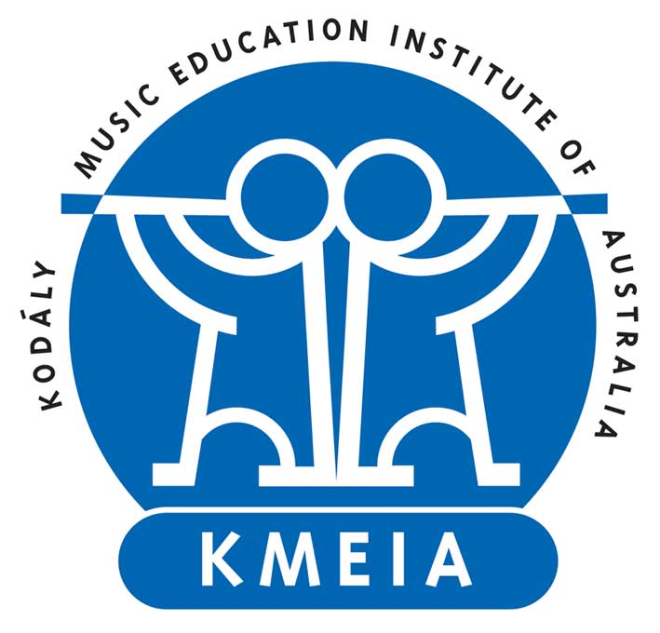
Kodály Music Education Institute of Australia
Australian Kodály Award and Certificate
Lecturer Accreditation Application Form

Please carefully read the Australian Kodály Award and Certificate Policy and Procedures document before completing this application form.

Personal Details
Title | Click or tap here to enter text.
Surname | Click or tap here to enter text.
Given Name | Click or tap here to enter text.
Date of Birth | Click or tap to enter a date.
Email | Click here to enter text.
Residential Address | Click here to enter text.
Home Phone | Click here to enter text.
Work Phone | Click here to enter text.
Mobile | Click here to enter text.
Nationality | Click here to enter text.
Have you previously applied? | Choose an item.
Are you amending current accreditation? | Choose an item.

Select which subjects and levels you are seeking accreditation.

Early Childhood  (includes Methodology, Teaching Techniques & Cultural Materials) | ☐ Level 1 | ☐ Level 2 | ☐ Level 3
Primary Class Music  (includes Methodology, Teaching Techniques & Cultural Materials) | ☐ Level 1 | ☐ Level 2 | ☐ Level 3
Secondary Class Music  (includes Methodology, Teaching Techniques & Cultural Materials) | ☐ Level 1 | ☐ Level 2 | ☐ Level 3
Colour Strings  (includes Methodology, Teaching Techniques & Cultural Materials) | ☐ Level 1 | ☐ Level 2 | ☐ Level 3
Musicianship | ☐ Level 1 | ☐ Level 2 | ☐ Level 3 | ☐ Level 4 | ☐ Level 5 | ☐ Level 6
Conducting | ☐ Level 1 | ☐ Level 2 | ☐ Level 3 | ☐ Level 4 | ☐ Level 5 | ☐ Level 6
Elective Studies | ☐ Choir | ☐ Other (please specify)

New applications
For new lecturer accreditation applications, please send the following:

- Lecturer Accreditation Application Form

- Curriculum vitae
Curriculum vitae listing
  - Academic qualifications
  - Relevant employment and experience
  - Publications
  - Relevant professional development attendance and presentations
  - Professional memberships
  - Other relevant information

- Written response
Your written response to the selection criteria (refer to Lecturer Accreditation Policy and Procedures) with supporting evidence
  - Address the mandatory criteria
  - Address the three subject and level criteria for each subject and level accreditation is being sought
  - Maximum 150 words for each criterion being addressed
  - Supporting evidence in digital format is required for each criterion of each subject and level. Examples of evidence include: lesson plans, curriculum documents, recorded video of teaching, student feedback sheets, academic transcripts, personal statements, professional references, teaching evaluations, presentation abstracts, professional development log.

- References
At least 2 written references with contact details completed by your:
  - Intended course provider
  - Mentor lecturer

Your references should affirm your written response.

Amendments to existing lecturer accreditation
For amendments to existing lecturer accreditation, please send the following with your application:

- Updated Lecturer Accreditation Form

- Updated Curriculum Vitae

- Your Written Response addressing criteria of the additional subject and level accreditation is being sought with supporting evidence.

- At least 1 written Reference (with contact details) affirming your written response.

Privacy
KMEIA’s Privacy Policy is available online. http://www.kodaly.org.au/privacy/

Submission
Send your application and documents to:

The Chair, Education Committee, KMEIA National Council
education@kodaly.org.au

Declaration
By signing below, I agree the information contained in this application to be true and accurate. The Education Committee may seek to clarify or request further information if necessary.

Signed: Click or tap here to enter text.

Date: Click or tap to enter a date.

